

# STUDENT MANAGEMENT SYSTEM

***Submitted by***

# RAVINDERAN K (231501135)

**SARVEESH B (231501148)**

# MINI PROJECT REPORT

**for**

**CS23333 - OBJECT ORIENTED PROGRAMMING USING JAVA**

**Department of Artificial Intelligence and Machine Learning**

**Rajalakshmi Engineering College, Thandalam.**

# BONAFIDE CERTIFICATE

Certified that this project report titled **“STUDENT MANAGEMENT SYSTEM”** is the

### BONAFIDE work of RAVINDERAN.K (231501133), SARVEESH.B (231501148), who

carried out the work under my supervision. Certified further that to the best of my knowledge the work reported herein does not form part of any other thesis or dissertation on the basis of which a degree or award was conferred on an earlier occasion on this or any other candidate.

**SIGNATURE SIGNATURE**

**Dr.Sekar K M.E., Ph.D, Mr. Devendar Rao.**

**HEAD OF THE DEPARTMENT FACULTY IN CHARGE**

**Department of Artificial Department of Artificial**

**Intelligence and Machine Learning, Intelligence and Machine Learning,**

**Rajalakshmi Engineering College, Rajalakshmi EngineerinCollege,**

**Thandalam, Thandalam,**

**Chennai-602 105. Chennai- 602 105.**

**Submitted to Project Viva-Voce Examination held on**

**Internal Examiner External Examiner**

# ABSTRACT

The **Student Management System** is a comprehensive desktop-based application designed to streamline and automate the management of student records in an educational institution. Built using **Java Swing** for the graphical user interface and **Oracle Database** for secure and scalable data storage, this system provides an efficient and user-friendly solution for managing student information.

The project focuses on core operations such as adding, updating, deleting, and viewing student details, including **Student ID**, **First Name**, **Last Name**, **Date of Birth (DOB)**, **Gender**, **CGPA**, **Address**, and **Email**. The integration of advanced Java libraries, such as **JCalendar** for date selection and **Oracle JDBC Connector** for database connectivity, ensures a seamless and robust user experience.

## Purpose and Motivation

Educational institutions often struggle with outdated or manual processes for handling student information. Such systems are prone to inefficiency, errors, and data loss, leading to challenges in maintaining accurate and consistent records. The primary motivation of this project is to replace these traditional methods with a fully automated system that is secure, scalable, and easy to use.

## Key Features and Functionalities

1. **Add New Records**: The system allows administrators to input student details through a graphical form with built-in validation to ensure the correctness of data.
2. **Update Records**: Existing student records can be modified with updated information while maintaining data integrity.
3. **Delete Records**: Administrators can remove outdated or irrelevant student data directly through the system.
4. **View Records**: Displays all stored student details in a tabular format with options for sorting and filtering.
5. **Validation**: Includes input validations for fields such as email, DOB, and CGPA to ensure proper data entry.
6. **Database Security**: Oracle Database is utilized to securely store and manage data, offering robust query execution and backup mechanisms.

## Significance of the Project

The **Student Management System** enhances productivity by automating repetitive tasks, reducing the chances of errors, and improving data accessibility. Its modular and scalable design ensures adaptability for future enhancements, such as integrating features like data export to Excel or remote database access.

**TABLE OF CONTENTS**

|  |  |  |
| --- | --- | --- |
| **CHAPTER NO** | **TITLE** | **PAGE NO** |
|  | **ABSTRACT** | i |
|  | **LIST OF FIGURES** | iii |
| **1** | **INTRODUCTION** | 1 |
|  | **1.1 Motivation** | 1 |
|  | **1.2 Existing System** | 1 |
|  | **1.3 Project Objectives** | 1 |
|  | **1.4 Proposed System** | 2 |
| **2** | **SYSTEM DESIGN** | 4 |
|  | **3.1 Introduction** | 4 |
|  | **3.2 System Architecture** | 4 |
|  | **3.3 System Requirements** | 5 |
| **3** | **PROJECT DESCRIPTION**   * 1. **Methodologies**   2. **Module Description** | 6  6  6 |
| **4** | **Results and Discussion** | 12 |
|  | **CONCLUSION** | 13 |

# LIST OF FIGURES

|  |  |  |  |
| --- | --- | --- | --- |
| **S.NO** | **FIG NO** | **FIG NAME** | **PG NO** |
| **1** | **3.1** | **Main Page** | **7** |
| **2** | **3.2** | **Adding data** | **8** |
| **3** | **3.3** | **After Adding** | **8** |
| **4** | **3.4** | **Update** | **9** |
| **5** | **3.5** | **After Updating** | **9** |
| **6** | **3.6** | **Updated Data** | **10** |
| **7** | **3.7** | **Deleting** | **10** |
| **8** | **3.8** | **After deleting** | **11** |
| **9** | **3.9** | **Deleted Data** | **11** |
| **10** | **4.1** | **Oracle Database** | **15** |

**Motivation of the Project**

# CHAPTER - 1 INTRODUCTION

The motivation behind developing the Student Management System stems from the growing need for an efficient, secure, and user-friendly solution to manage student records in educational institutions. With the increasing number of students, courses, and associated data, traditional manual or semi-digital systems have proven to be inadequate. This project aims to overcome the limitations of existing methods and provide a robust and scalable alternative.

### Addressing Limitations of Existing Systems

* + **Data Accuracy**: Manual systems are prone to human errors, leading to inaccuracies in student records. This project is motivated by the need to eliminate such errors through automation and validation mechanisms.
  + **Operational Efficiency**: Tasks like adding, updating, and retrieving student records are time-consuming in traditional systems. The proposed system seeks to automate these operations, reducing the administrative workload.
  + **Data Accessibility**: In manual or semi-digital systems, accessing student records is often slow and limited to specific locations or files. This project aims to enable real-time data access, making information retrieval faster and more efficient.

### Improving Data Security

* + Educational institutions handle sensitive student information, including personal details, academic records, and contact information. However, manual and semi-digital systems lack robust security measures, leaving data vulnerable to loss or unauthorized access. The motivation for this project lies in implementing a secure database system (Oracle) to ensure data confidentiality, integrity, and availability.

**Project Objectives**

The **Student Management System** project has been designed with the following key objectives in mind:

### Providing a User-Friendly Interface

* + The system aims to simplify student record management by offering an intuitive and visually appealing **Graphical User Interface (GUI)** built using **Java Swing**.
  + The interface is designed for non-technical users, ensuring ease of navigation and usability.
  + Key features include form-based input for data entry, table views for displaying records, and buttons for CRUD (Create, Read, Update, Delete) operations.

### Automating CRUD Operations

* + One of the primary goals is to automate repetitive administrative tasks to save time and effort.
  + CRUD functionalities allow administrators to:
    - **Create**: Add new student records.
    - **Read**: View all existing student records in a tabular format.
    - **Update**: Modify specific details of a student (e.g., CGPA, email, address).
    - **Delete**: Remove outdated or invalid student records.
  + Automation eliminates the need for manual record-keeping, reducing human errors and improving efficiency.

### Ensuring Data Security

* + The system incorporates a **robust Oracle Database** to store and manage student records securely.
  + Secure access to the database is ensured through **Oracle JDBC Connector**, which restricts unauthorized access.
  + Sensitive data like student personal details and email addresses are protected using the database's in-built security features.

### Maintaining Data Integrity

* + The system implements validation mechanisms to ensure the accuracy and reliability of data.
  + Examples of data validation:
    - **Email Validation**: Ensures the entered email address is in the correct format.
    - **CGPA Range**: Limits the CGPA to a valid range (e.g., 0.0 to 10.0).
    - **Date Validation**: Uses **JCalendar** to prevent invalid date entries for DOB.
  + Consistency in data entry reduces the risk of errors and ensures the integrity of the stored information.

### Enhancing Scalability

* + The system is designed to handle increasing volumes of data as the institution grows.
  + Features like modular database design and efficient query execution make it adaptable for future requirements (e.g., adding new fields like emergency contact or course history).

### Proposed System

The **Proposed System** focuses on delivering a modern and efficient solution to overcome the limitations of the existing manual or semi-digital systems. Below are the key aspects of the proposed system:

### Automation of Tasks

* + The system automates critical operations related to student record management, such as adding, updating, deleting, and retrieving data.
  + Eliminates repetitive manual work, reducing administrative workload and improving productivity.
  + Tasks are executed in real-time, ensuring instant updates to the database.

### Seamless Data Handling

* + The proposed system uses **Oracle Database** to manage and store student information securely and efficiently.
  + Features include:
    - **Structured Tables**: The database is organized into well-defined tables with fields for each student attribute (e.g., ID, Name, DOB, Gender, CGPA, Address, Email).
    - **Real-Time Access**: Data retrieval and updates occur instantaneously, allowing for smooth interaction between the user interface and the database.
    - **Dynamic Updates**: Changes made to student records (e.g., updating an address or deleting a record) are reflected immediately.

### Robust Database for Secure Storage

* + The **Oracle Database** serves as the backbone of the system, ensuring secure and reliable data storage.
  + Key features of the database design:
    - **Primary Keys**: Ensures each student record is unique (e.g., Student ID as the primary key).
    - **Constraints**: Implements validation rules at the database level to prevent invalid entries.
    - **Data Backup**: Oracle's built-in features allow for regular backups, reducing the risk of data loss.
    - **Role-Based Access Control**: Ensures that only authorized users can access or modify the database, enhancing security.

### User-Friendly Features

* + The **Java Swing** interface provides an easy-to-use environment for interacting with the system.
  + Features include:
    - **JCalendar**: Integrated for date selection, ensuring accurate DOB input.
    - **Buttons and Forms**: Simplifies CRUD operations with clearly labeled buttons like "Add," "Update," "Delete," and "View."
    - **Table View**: Displays all student records in a structured format, with options for sorting and filtering.

### Validation Mechanisms

* + The system incorporates both front-end and back-end validation to ensure accurate data handling.
  + Examples of validations:
    - **Front-End Validation**: Checks user inputs before sending data to the database (e.g., email format, DOB selection).
    - **Back-End Validation**: Adds an extra layer of protection by applying constraints within the database schema.

# CHAPTER 2 SYSTEM DESIGN

Chapter 2 focuses on the detailed architecture, flow, and technical requirements of the **Student Management System**. It provides a comprehensive overview of the system’s structure and design. Below is a detailed explanation of each heading under this chapter:

## Introduction

This section introduces the concept of system design and explains its importance in the development process:

* + - **Purpose of System Design**: Ensures that the application meets the defined objectives and functions effectively by creating a blueprint of the system.

### Key Focus Areas:

* + - * How various components (e.g., user interface, database) interact.
      * Ensuring scalability, security, and usability.
    - **Relevance to the Project**: In the context of the **Student Management System**, system design involves planning the architecture, database schema, user interface, and data flow.

## System Architecture

This section provides an overview of the system's architecture, explaining the interaction between different layers:

### Three-Layered Architecture:

1. **Presentation Layer (Frontend)**:
   * Built using **Java Swing**.
   * Provides the graphical user interface for interacting with the system (e.g., adding, updating, or viewing student records).

### Application Layer (Logic):

* + The core logic written in **Java** connects the frontend to the backend.
  + Handles operations like input validation, database queries, and processing CRUD operations.

### Data Layer (Backend):

* + An **Oracle Database** stores all student-related data securely.
  + Managed through **Oracle JDBC Connector**, which allows communication between the application and the database.
    - **Flow**: User inputs data → Application processes the input → Data is stored/retrieved from the database.

## System Requirements

This section specifies the hardware and software requirements for developing and running the system:

### Hardware Requirements

* + - **Processor**: Minimum Dual Core or higher for faster processing.
    - **RAM**: Minimum 4GB; recommended 8GB for smooth application execution.
    - **Storage**: At least 500MB for program files and database storage.

### Software Requirements

* + - **Operating System**: Windows 10 or higher / Linux.

### Development Tools:

* + - * **JDK (Java Development Kit)**: For coding and compiling the application.
      * **Java Swing**: For creating the GUI.
      * **JCalendar Library**: For date selection in forms.
      * **Oracle JDBC Connector**: To enable database connectivity.
    - **Database**: Oracle 11g or higher for data storage.

## Database Design

This section explains the structure of the database and its role in managing student records efficiently:

* + - **Database Schema**: Defines the tables, fields, and relationships within the database.

### Student Table:

* + - * **Columns**:
        + Student_ID (Primary Key): Unique identifier for each student.
        + First_Name, Last_Name: For storing the student's full name.
        + DOB: Date of Birth (validated using JCalendar).
        + Gender: Stores the gender of the student (e.g., Male, Female, Other).
        + CGPA: Stores the cumulative grade point average (validated for correct range).
        + Address: Stores the residential address.
        + Email: Stores the student's email (validated for correct format).
      * **Relationships**: Single-table structure for simplicity but can be extended for relationships (e.g., linking courses or departments).

### Constraints:

* + - * **Primary Key**: Ensures each record is unique (e.g., Student_ID).
      * **Not Null**: Mandatory fields such as Name, DOB, and CGPA.
      * **Check Constraints**: Validates CGPA and DOB fields.

## Data Flow Design

This section illustrates how data flows through the system and ensures efficient interaction between components:

### Data Flow Diagram (DFD):

* + - * **Level 0**: High-level overview of the system (inputs and outputs).
      * **Level 1**: Explains the core processes like adding, updating, and deleting student records.

### Workflow:

1. User interacts with the frontend (e.g., fills a form or clicks a button).
2. The application logic validates the input.
3. The Oracle JDBC Connector sends SQL queries to the database.
4. Data is stored, retrieved, or modified in the database.
5. The output is displayed on the frontend in real-time.

### CHAPTER 3 PROJECT DESCRIPTION

Chapter 3 provides an in-depth explanation of the **Student Management System**, including the methodologies used, detailed module descriptions, and results and discussions. Below is a breakdown of each heading:

## Methodologies

This section explains the methodologies and techniques applied during the development of the project.

### Software Development Lifecycle (SDLC)

* + **Model Used**: Waterfall Model
    - Requirements were gathered first, followed by design, implementation, testing, deployment, and maintenance.
    - Sequential approach ensured that each stage was completed before moving to the next.

### Object-Oriented Programming (OOP) Principles

The project used **OOP concepts** for better structure and reusability:

* + **Encapsulation**: Restricted direct access to student attributes by using getter and setter methods.
  + **Inheritance**: Reused functionality in different parts of the system.
  + **Polymorphism**: Allowed methods like saveStudent() and updateStudent() to handle multiple types of operations.
  + **Abstraction**: Simplified database connectivity by abstracting it into utility classes.

### Java Swing for GUI

* + Used for creating a dynamic and interactive graphical user interface.
  + Included components such as forms, buttons, and tables.

### Oracle Database

* + Managed relational data with a well-structured schema.
  + SQL queries were used for CRUD operations.

### Integration with Oracle JDBC

* + Established communication between the Java application and Oracle Database.
  + Handled database connections, queries, and result sets efficiently.

## Module Descriptions

This section details the various modules in the **Student Management System** and their functionalities.

### Login Module

* + **Purpose**: Authenticates users before granting access to the system.

### Key Features:

* + - Username and password validation.
    - Security measures to prevent unauthorized access.

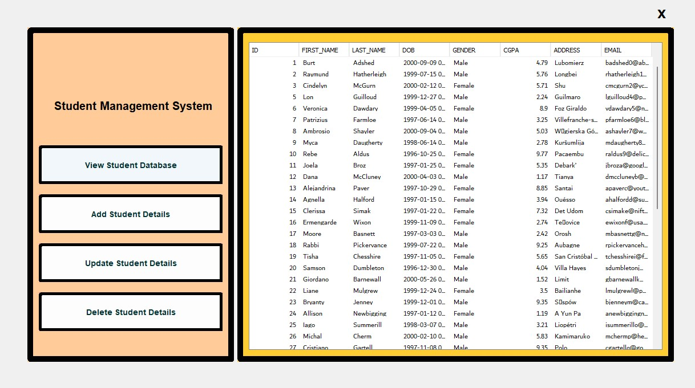

### Fig :3.1 Main page

1. **Add Student Module**
   * **Purpose:** Enables users to input new student records.

### Features:

* + - Form-based input for student details like ID, first name, last name, DOB, gender, CGPA, address, and email.
    - Validation for mandatory fields and formats (e.g., CGPA range, email format).
    - Data is stored in the Oracle database**.**

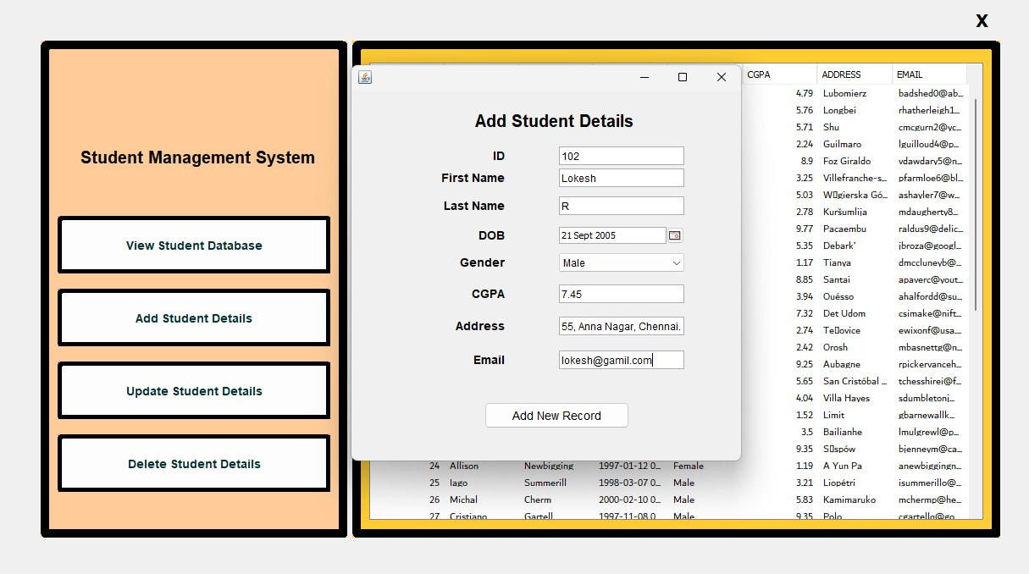

### Fig3.2 Adding Data

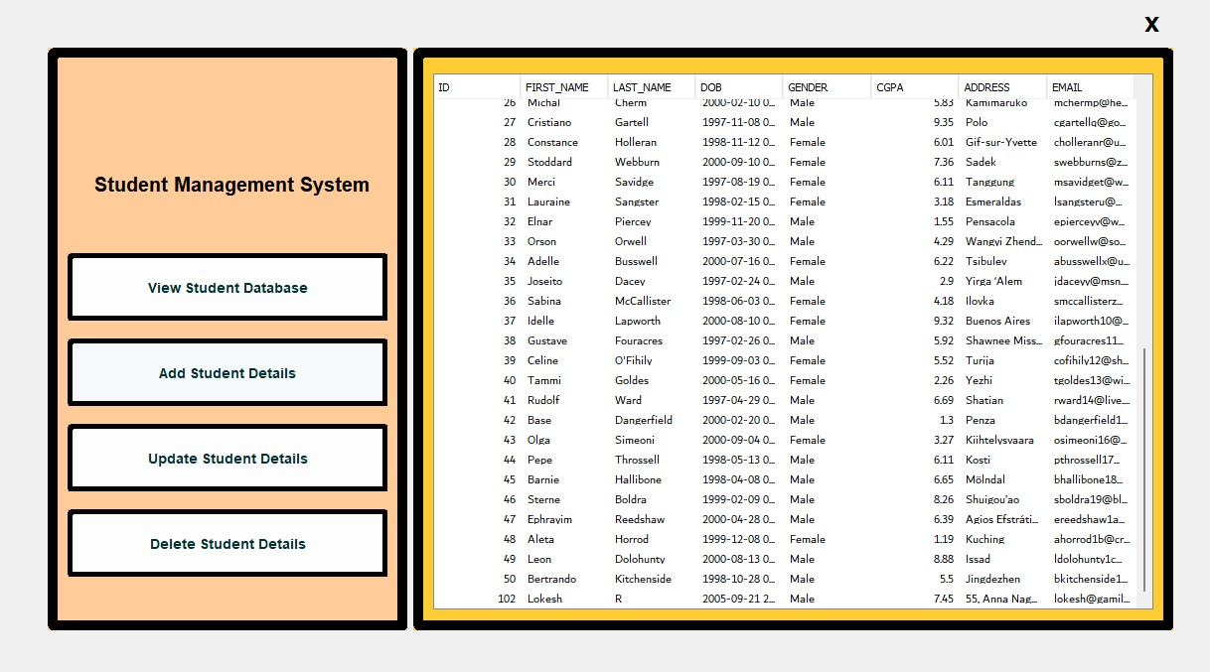

**Fig 3.3 After Adding Data**

### Update Student Module

* + **Purpose**: Allows modification of existing student records.

### Features:

* + - Search functionality to locate a student by ID or name.
    - Editable fields for updating information such as address, CGPA, or email.
    - Real-time reflection of changes in the database.

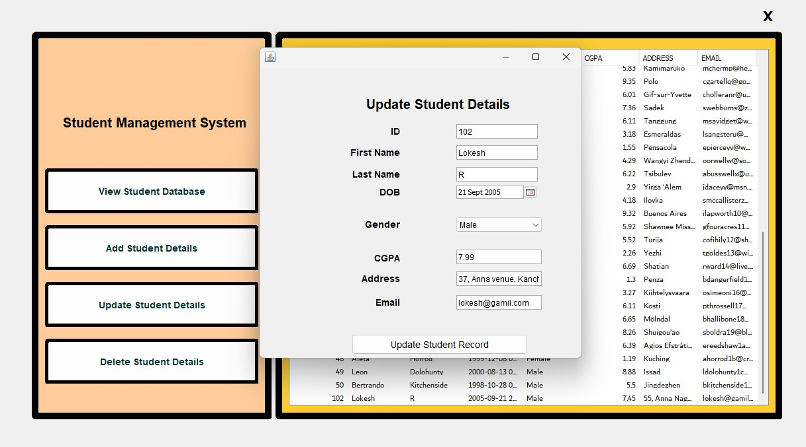

### Fig 3.4 Updating

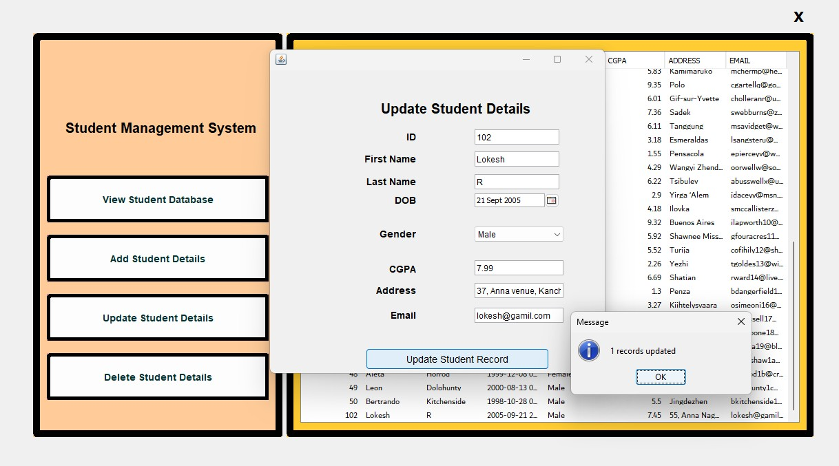

**Fig 3.5 After Updating**

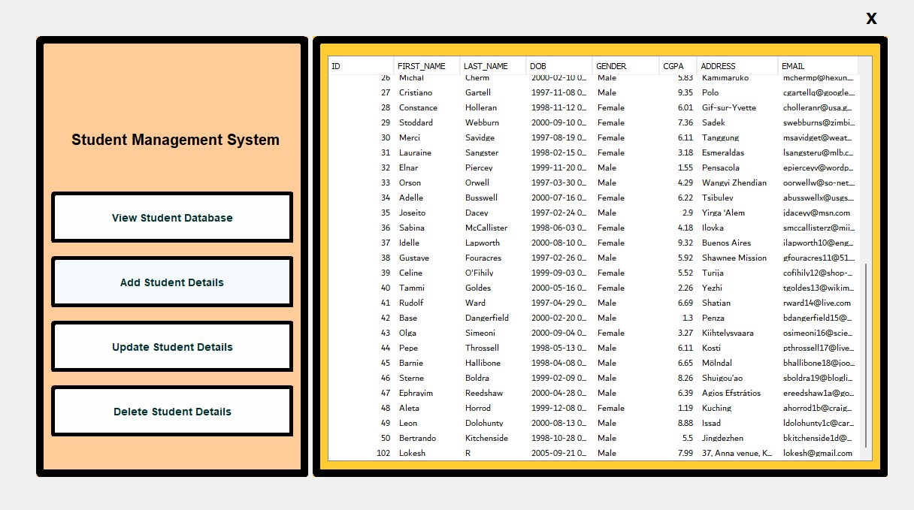

### Fig 3.6 Updated

1. **Delete Student Module**
   * **Purpose:** Removes outdated or invalid records.

### Features:

* + - Users can search for a student by ID or name.
    - Confirmation dialog to prevent accidental deletions.
    - Deletion cascades across related tables if relationships exist.

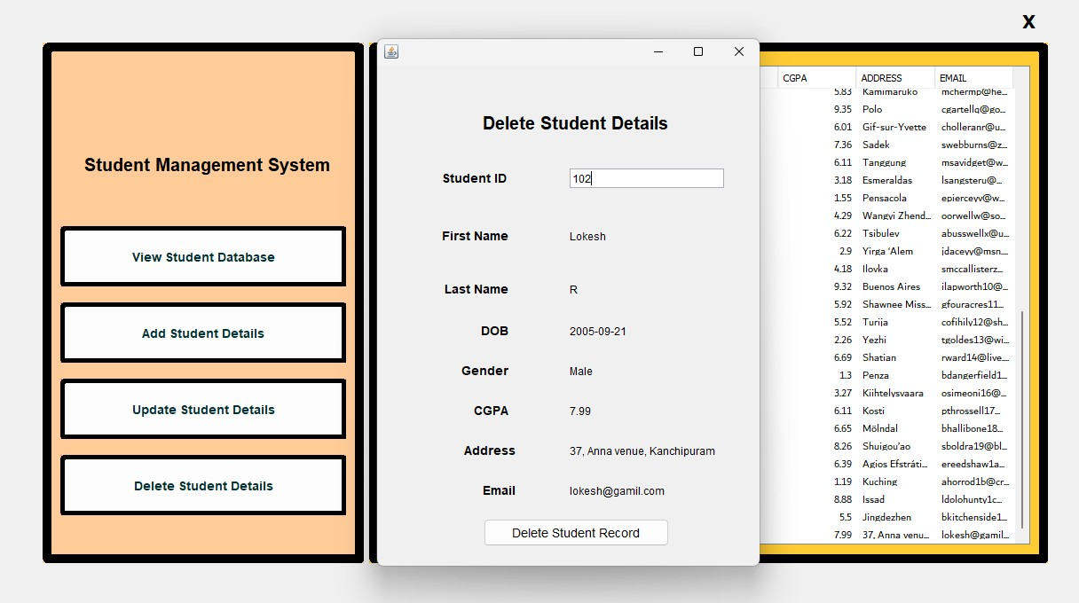

### Fig 3.7 Delete data

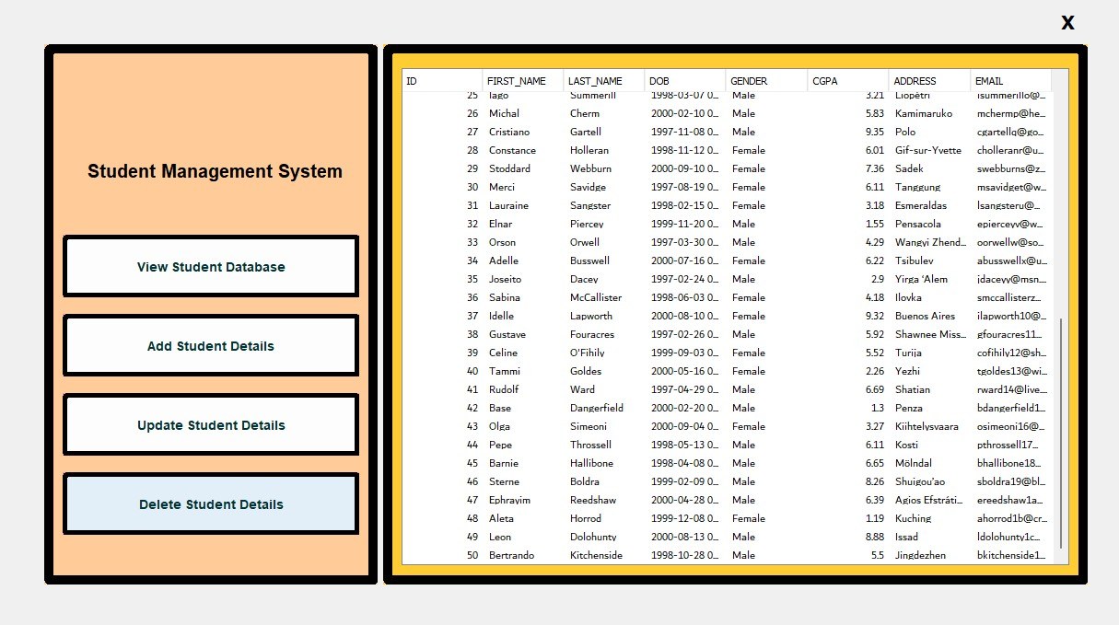

**Fig 3.8 After deleting data**

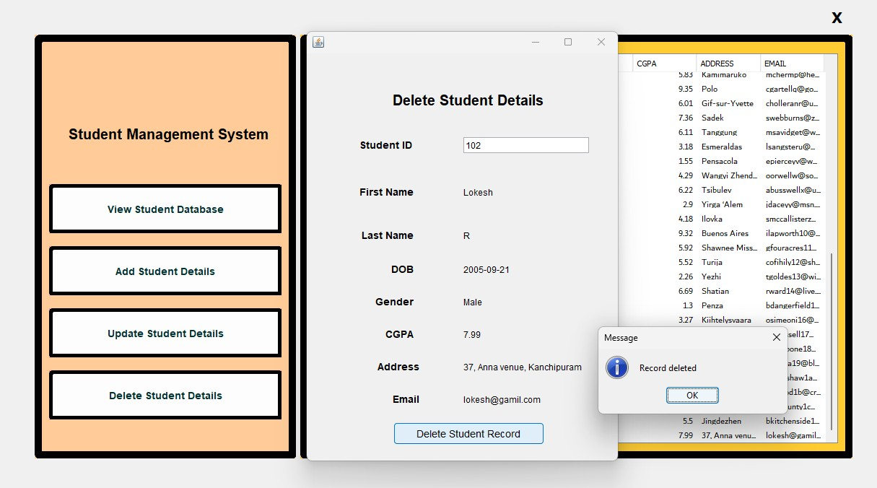

**Fig 3.9 Deleted data**

## Results and Discussion

This section discusses the outcomes of the project and evaluates its effectiveness.

### System Functionality

* + The system successfully implements CRUD operations:
    - Adding, viewing, updating, and deleting student records.
    - All changes are instantly reflected in the Oracle database.

### User Experience

* + The Java Swing GUI provides a user-friendly interface:
    - Easy navigation and clear labeling of buttons.
    - Minimal errors due to validation mechanisms.

### Data Security

* + The use of Oracle Database ensures secure storage of data.
  + Authentication mechanisms prevent unauthorized access to the system.

### Performance

* + The system performs efficiently with quick response times for CRUD operations.
  + Scalable to handle a larger number of students as needed.

### Challenges Encountered

* + Database Connectivity Issues: Debugging JDBC configuration required additional time.
  + Validation Complexity: Ensuring robust validation for all fields was challenging but resolved.
  + UI Design: Designing a clean and intuitive interface using Java Swing involved iterative improvements.

### Future Scope

* + Integration with cloud-based databases for enhanced scalability.
  + Addition of analytics and reporting tools for better decision-making.
  + Integration of role-based access control (e.g., admin, teacher, student)
  1. **Libraries Needed**

# CHAPTER 4 CONCLUSION

This section describes the external libraries and tools integrated into the project:

### JCalendar Library:

* + - * Purpose: Provides a graphical calendar widget for selecting dates (e.g., Date of Birth).
      * Integration: The library is used in the student form to simplify and validate date input.

### Oracle JDBC Connector:

* + - * Purpose: Facilitates the connection between the Java application and Oracle Database.
      * Functionality:
        + Executes SQL commands (e.g., INSERT, UPDATE, DELETE, SELECT) to interact with the database.
        + Ensures secure and efficient communication between the application and backend.

### Oracle Database:

* + - * Purpose: Serves as the backend to store, retrieve, and manipulate student data.
      * Features:
        + Stores data in a structured manner.
        + Ensures data integrity and supports large-scale data handling.

**Connectivity of Frontend and Backend in the Student Management System**

In this project, the connection between the frontend (Java Swing) and the backend (Oracle Database) is established using **Java Database Connectivity (JDBC)**. Here's a brief explanation of the process:

### Frontend (Java Swing):

* + The user interacts with the system through a graphical user interface (GUI) built using Java Swing.
  + Actions like adding, updating, deleting, or viewing student records trigger events in the frontend.

### Backend (Oracle Database):

* + The Oracle Database stores student details, such as ID, name, DOB, CGPA, etc.
  + All data operations (CRUD) are performed directly on the database.

### Connectivity via JDBC:

* + **JDBC Driver**: The Oracle JDBC driver (ojdbc.jar) is used to establish a connection between the Java application and the Oracle Database.

### Connection Steps:

* + - Load the JDBC driver

using Class.forName("oracle.jdbc.driver.OracleDriver").

* + - Establish a connection using DriverManager.getConnection() with the database URL, username, and password.
  + SQL queries (e.g., INSERT, UPDATE, DELETE, SELECT) are executed using PreparedStatement or Statement objects.
  + Results are fetched from the database and displayed in the Swing GUI (e.g., in a JTable).

### Example Workflow:

* + **Adding Data**:
    - The user fills out a form and clicks "Add."
    - The input is validated in the frontend.
    - A SQL INSERT query is sent via JDBC to the database to store the record.

### Retrieving Data:

* + - The system sends a SQL SELECT query to fetch records.
    - The results are displayed in a table on the GUI.

This integration ensures seamless communication between the user-facing application and the database, enabling efficient data management.

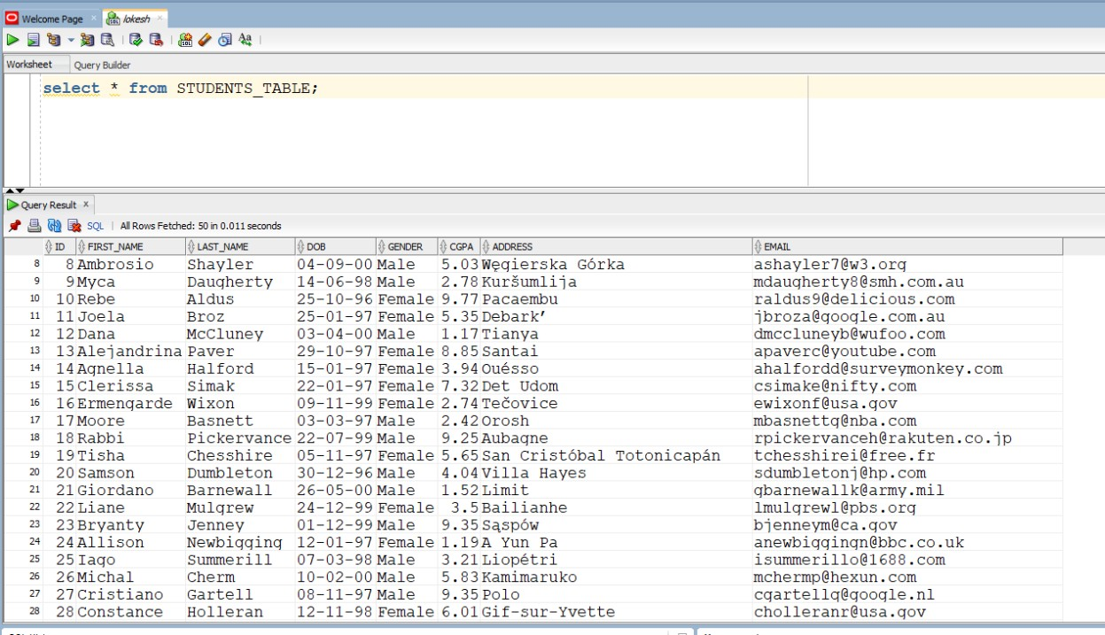

**Fig 4.1 Oracle Database**

## Conclusion of Student Management System

The Student Management System is a robust application that simplifies the process of managing student data within educational institutions. Developed using Java Swing for the frontend and Oracle Database as the backend, the system successfully addresses the inefficiencies and challenges of traditional, manual processes for handling student records. This project integrates modern technologies to deliver a scalable, efficient, and user-friendly solution for student data management.

### Key Accomplishments

1. **Streamlined Student Data Management:**

The system enables administrators to efficiently manage student data, including adding, updating, deleting, and viewing records. By replacing traditional manual processes, the project ensures faster and more accurate data handling.

### Improved Data Security and Integrity:

By using Oracle Database as the backend, the project ensures that student data is stored securely and remains consistent. The use of validations and error handling minimizes the chances of incorrect or duplicate entries.

### User-Friendly Interface:

The graphical user interface built with Java Swing provides an intuitive and straightforward way for users to interact with the system. Features like drop-down menus, forms, and a tabular display of data enhance usability and accessibility.

### Efficient Data Connectivity:

The integration of the Oracle JDBC Connector ensures seamless communication between the frontend and backend. The use of prepared SQL queries makes the system both secure and efficient in performing CRUD operations.

### Extensibility:

The modular design of the application lays the foundation for future enhancements. New features, such as advanced search, data export, or integration with online systems, can be easily added without disrupting the existing functionality.

## Challenges Addressed

The project addresses several challenges associated with traditional methods of managing student records:

* **Time-Consuming Processes:** Manual data entry, updating, and retrieval are slow and prone to errors. The system automates these tasks, significantly reducing time and effort.
* **Data Inconsistency:** Centralized storage ensures that all data is consistent and updated in real-time.
* **Lack of Security:** Unlike paper-based or spreadsheet systems, this project offers improved security by storing data in a password-protected database.
* **Human Errors:** Real-time validation of inputs (e.g., ensuring a valid email format or CGPA range) minimizes errors during data entry

## Benefits of the System

1. **Automation:** Automating CRUD operations reduces the workload on administrators, allowing them to focus on more critical tasks.
2. **Data Validation:** Validation mechanisms ensure that only correct and meaningful data is stored in the system, improving the quality of records.
3. **Accessibility:** Users can easily retrieve and manage student data through an organized and interactive interface.
4. **Reliability:** The use of Java and Oracle ensures that the application is both stable and capable of handling large amounts of data without performance issues.

## Future Enhancements

While the current system achieves its primary objectives, there is scope for improvement and expansion:

1. Search and Filter Options: Adding advanced search and filtering capabilities would help administrators quickly find specific student records.
2. Export and Reporting: The system could generate reports in formats such as PDF or Excel for academic analysis or record-keeping.
3. Online Integration: Integrating the system with online portals or cloud-based services could provide access to data from remote locations.
4. Role-Based Access Control: Adding user roles (e.g., admin, teacher, viewer) would enhance security and limit access to sensitive data.
5. Mobile Application: A mobile version of the system could improve accessibility for administrators on the go.

## Conclusion

In conclusion, the Student Management System demonstrates the power of integrating programming and database technologies to solve real-world problems. By automating and simplifying the management of student records, the project has significant implications for educational institutions, helping them to operate more efficiently and effectively.

The project’s success lies in its ability to meet the objectives of data accuracy, security, and usability. It provides a centralized solution that streamlines administrative processes while ensuring that data is well-organized and secure. The use of Java Swing for the frontend and Oracle Database for the backend demonstrates how robust and scalable applications can be built using these technologies.

Finally, this project serves as a foundation for future development and innovation. With enhancements like online integration, data analytics, and advanced reporting, the system can evolve into a comprehensive tool that caters to broader educational management needs. It is a testament to how technology can improve operational efficiency and drive progress in educational institutions.